–Commands os
Touch “name.txt” – create a file
Ls – list the files In the current directory
Cd - to go through directories
Mkdir “source” – create a directory
Ls -l - show the permissions for each file
. – current directory
.. – previous directory
Pwd – print where you are in the file system – path directory
Cp – copy files and directories
Cp “source” “destination”
Ctrl C – to close the program or the continuous blinking of the cursor
Mv “source” “destination” – to move a file to another place, it can also be used for renaming files
Rm “source” – to remove a file
Rm -fr / - it means I want to delete everything!! DON’T DO THAT!! ALL THE FILES WILL BE DELETED TOGETHER WITH THE OPERATING SYSTEM
Echo “characters”– prints characters
Echo $HOME – prints the home path
Rmdir “dir”- remove an empty directory
Rm -r “dir” – remove a directory with all its content
Ps – will show the processes at this moment
Ctrl z – stops the process but it doesn’t kill it so it is still in the background
Kill -9 pid of the process – kills the process
Ps -ef | head -20 – it will print only the first 20 processes
Ps -ef | tail -20 – it will print only the last 20 processes
Ps -ef | grep “name” – it will show only the processes created by name or which contain name
Ps -ef | grep “name” | sort – it will show them sorted
Ps -ef | grep “name” | sort | wc -l – counts the lines and prints the number
Top – is like task manager in windows
Df
Du
Who – shows who is active at the moment (users)
Last – shows everybody who was logged in and if they are still logged in
> “file” – redirect something in a file
Cat file – concatenates files and prints the content of the file
Ctrl s - blocks the console
Ctrl q – unblocks the console
Chmod -x “file_name” – makes the file executable
Chmod -X “file_name” – makes the file unexcutable
Chmod xxx “file_name” – changes the permission, xxx – is a number, like 755, considered on bits 111_101_101
rwx_r - x_r - x
A file is executable if at the end of the first column from ls -l we have ‘x’
Cat “file” | wc (word count) -l (Numara cuvinte dar de fapt linii) - shows how many lines there are in a file
Test – citeste manualul legat de comanda asta
Less /etc/passwd – shows everyone who was connected at the server
Cut -d: f5 /etc/passwd – gives you the field 5
Uniq – will remove the duplicates from a sorted source (THE SOURCE MUST BE SORTED!!!)
Ex: grep -E “ – 911 – “ |sort |uniq
…|sort|uniq|-c – shows the number of appearances in front of the word
|sort -n – numeric sort
|sort -n – r – reverse numeric sort (descending sorting)
|tail -n +number – shows the lines starting with the index number
Getpid() – get the id of the current process
Getppid() – get the id of the parent process
Kill -9 no_of_process – kill the process
ipcs – shows the shared memory undeleted
ipcmk -M 1024 -p 600 – how much memory you want and the permission
ipcrm shm 6 – it deletes the shared memory you want

IF YOU DECLARE VARIABLES, DON’T PUT SPACES!!!!!! THEY WON’T BE RECOGNIZED!!!!!!!
history | tail -n <cate comenzi vr> > file - va salva ce comenz am dat in terminal in file

REGULAR EXPRESSIONS:
GREP
- ^(.{2})*.$ - Găsiți toate liniile cu număr impar de caractere dintr-un fișier dat.
Sau ^\(..\)\+S
- [a-zA-z]*[^aeiou\d\s\W]{3}[a-zA-Z]* - Extrageți cuvintele cu 3 consoane consecutive dintr-un text.
Sau \b[\w]*[^aeiou\d\s\W]{3}[\w]*\b
sed s/da/nu/g lab2-sed - substitute da with nu ( g means all the occurrences on the same line)
if we add -i, the new format will be placed in the format, using -i the given file is overwritten
SED
- sed s/^/abc/g lab2-sed - Prefixați fiecare linie dintr-un fișier cu abc
- sed s/^$/empty/g lab2-sed - Inlocuiți fiecare linie goală dintr-un fișier cu �empty�.
- sed 's/\t/ /g' lab2-sed sau sed -E $'s/\t/ /g' sau sed "s/\t/ /g" lab2-sed - Convertiți taburile �n 3 spații �ntr-un text dat.
- sed -E 's/(.)(.)(.)/\2\3\1/g' lab2-sed - Rotiți cu o poziție fiecare triplet de caractere dintr-un fișier.

AWK
awk -F: '$3 % 2 == 0 {print $5}' /etc/passwd | awk -F- '{print $3}' – separa dupa : si filtreaza dupa coloanal 3 para iar apoi separa dupa – si afiseaza doar coloanal 5

If you type vim – it will start a file to print a piece of code
Vim “file name”- press i to start typing the code
Esc +
:w “file name” – gives to your program file a name
:wq – save and exit
Cat “filename.c” – shows what is written in the file
:w “filename” – imi pune nume de fisier la fisierul tocmai scris pe care nu il am
:q – quits the file
Gcc -Wall -o hello.out hello.c
The first file is the output file and it will have the prints from hello.c
To see what you have in that file you write ./hello.out
Gcc -Wall -Wextra -Werror -g -o (-o means output) a “file t compile” – it shows the warnings and the errors from a compiling file (i-am zis la output sa fie a deci fisierul de iesire va fi a)
ESC gg=G format the code with indentation and all
Syntax on makes the words colorful

Din
Int sir[100] - in c++
Avem
Int *sir = malloc(100 * sizeof(int)) – in C aici alocam (se aloca in memorie pe heap)
Free(sir) aici trebuie eliberat ce alocam

Int **matrice;
Int matrice[10][10]
Matrice = malloc(10 * sizeof(int*)) – am alocat prima paranteza [10]
For (int i = 0; i < 10; ++i )
Matrice[i] = malloc(10 * sizeof(int))
…
For (int i = 0; i < 10; ++i )
Free(matrice[i])
Free(matrice)

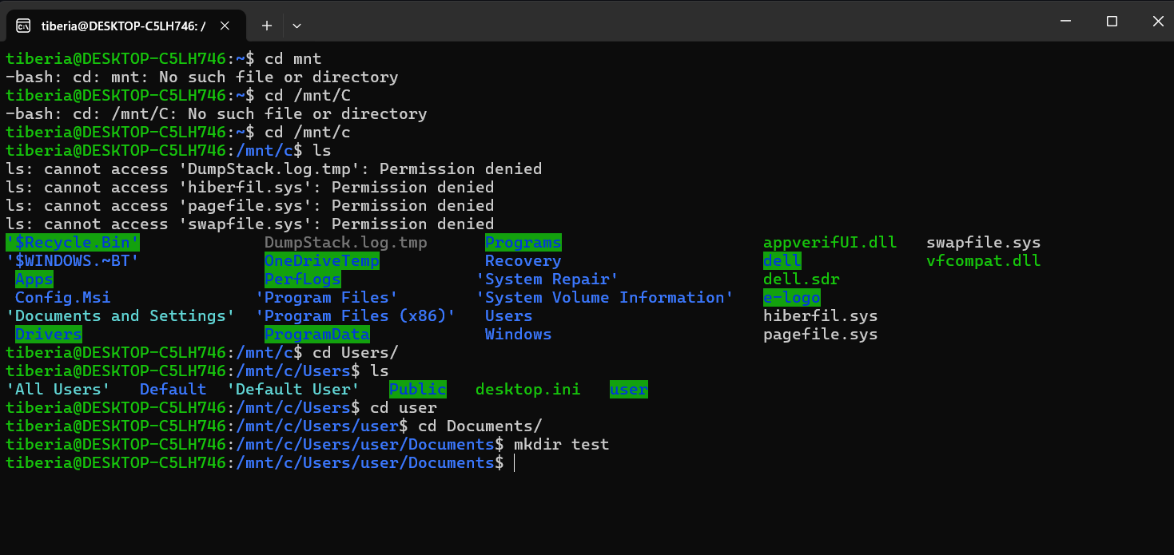

Syntax C
Int f = open(argv[1], O_RDONLY);
Read(file_descriptor -> f, buffer -> &rows, size -> sizeof(int));
You read an entire vector
Read(f, v[i], cols * sizeof(int));
FILE *f = fopen(path_name -> argv[1], mode_access -> “r”);
Fscanf(file_descriptor -> f, readable_type -> “%d”, buffer -> &rows);

- D�ndu-se un fișier �n care fiecare linie conține cel puțin două numere separate de spații, calculați următoarele:
  - suma primelor două numere de pe fiecare linie
  - suma primelor două numere de pe liniile impare
  - suma primelor două numere de pe liniile impare și cu mai mult de 5 numere
  - suma numerelor din prima coloană a fișierului
  - suma tuturor numerelor din fișier
- awk '{print $1+$2}' lab-ex3
- awk 'NR % 2 == 1 {print $1+$2}' lab-ex3
- awk 'NR % 2 == 1 && NF <= 5 {print $1+$2}' lab-ex3
- awk '{sum+=$1} END {print sum}' lab-ex3
- awk '{for(i=1; i<=NF; ++i) sum += $i} END {print sum}' lab-ex3
citeste despre MUTEX

PIPE – canal de comunicare UNIDIRECTIONAL
Pipeul trebuie declarat inainte de fork pentru ca in pipe vo mavea file descriptorii care sunt atasati de acea parte de memorie si de aceasti file descriptori va fi nevoie si in procesele copil.

Un fifo ca sa simuleze comportamentul unui pipe trebuie sa fie deschis in ambele capete !

